SUPPLEMENTARY MATERIALS
Table S1. List of PFAS analyzed, their corresponding acronyms, limit of detections (LOD) in serum and urine.
Analyte ª | Acronym | LOD in serum (ng/mL) | LOD in urine (ng/ml)
Perfluoropentanoic acid | PFPeA | 0.08 | ND
Perfluorohexanoic acid | PFHxA | 0.07 | 0.1(b)
Perfluoroheptanoic acid | PFHpA | 0.05 | 0.01
Perfluorooctanoic acid | PFOA | 0.09 | 0.01
Perfluorononanoic acid | PFNA | 0.05 | ND
Perfluorodecanoic acid | PFDA | 0.09 | ND
Perfluoroundecanoic acid | PFUnDA | 0.1 | ND
Perfluorododecanoic acid | PFDoA | 0.2 | ND
Perfluorotridecanoic acid | PFtrDA | 0.2 | ND
Perfluorobutane sulfonic acid | PFBS | 0.05 | 0.1 (b)
Perfluoropentane sulfonic acid | PFPeS | 0.02 | 0.01
Perfluorohexane sulfonic acid | PFHxS | 0.1 | 0.01
Perfluoroheptane sulfonic acid | PFHpS | 0.1 | 0.01 (b)
Linear perfluorooctane sulfonic acid | L-PFOS | 0.2 | 0.01
Perfluoro-1-methylheptanesulfonate | 1m-PFOS | 0.05 | 0.01
Perfluoro-3/4/5-methylheptanesulfonate (∑) | 3/4/5m-PFOS^{c} | 0.01 | 0.02
Perfluoro-2/6-methylheptanesulfonate (∑) | 2/6m-PFOS^{d} | 0.3 | 0.02
Perfluorononane sulfonic acid | PFNS | 0.05 | ND
Perfluorodecane sulfonic acid | PFDS | 0.1 | ND
- Details of the modified method was reported by Xu et al. (2020).
b: estimated from urine matrix.
c. 3/4/5m-PFOS corresponds to the sum of 3m-PFOS, 4m-PFOS and 5m-PFOS
d. 2/6m-PFOS corresponds to the sum of 2m-PFOS and 6m-PFOS
ND: not determined .

Table S2. Number of participants of urine/serum ratio in slow and fast groups in different sampling round.
 | slow in first two rounds | fast in first two rounds | percentage of remain in the same category | Slow in all three rounds | fast in all three rounds | percentage of remain in the same category
PFOA | 34 | 36 | 80% | 22 | 18 | 65%
PFPeS | 31 | 31 | 70% | 22 | 12 | 55%
PFHxS | 29 | 29 | 66% | 19 | 16 | 56%
PFHpS | 30 | 28 | 66% | 18 | 14 | 52%
L-PFOS | 34 | 33 | 76% | 21 | 15 | 58%
1m-PFOS | 28 | 28 | 64% | 15 | 10 | 40%
3/4/5m-PFOS | 31 | 28 | 67% | 19 | 14 | 53%
2/6m-PFOS | 30 | 29 | 67% | 15 | 9 | 39%
Note: Based on the paired urine and serum concentration, their ratios were calculated. Based on the ratios, one participant could be classified as having slow or fast group depending on its relation to the median of the ratios.

Table S3. Population average constant elimination rate (per year) and half-life (in years) for each PFAS without correction of background exposure.
 | Elimination Rate Constant (95%CI) | HL (95% CI)
PFOA | -0.23 (-0.25, -0.22) | 2.99 (2.79, 3.21)
PFPeS | -0.72 (-0.78, -0.67) | 0.96 (0.89, 1.03)
PFHxS | -0.15 (-0.17, -0.14) | 4.55 (4.17, 5.01)
PFHpS | -0.15 (-0.17, -0.14) | 4.61 (4.2, 5.12)
PFOS | -0.24 (-0.26, -0.23) | 2.87 (2.7, 3.06)
1m-PFOS | -0.14 (-0.15, -0.12) | 5.01 (4.56, 5.55)
3/4/5m-PFOS | -0.2 (-0.22, -0.19) | 3.43 (3.19, 3.71)
2/6m-PFOS | -0.26 (-0.28, -0.24) | 2.67 (2.51, 2.85)

Table S4. Estimated half-lives in groups divided by initial PFAS levels, n=114
 | initial total PFAS | rate with CI | diff with CI | p | HL with CI | diff HL%
PFOA | tertile 1 | -0.3(-0.36, -0.24) | -0.03(-0.09, 0.02) | 0.25 | 2.29(1.92, 2.83) | -11.24%
 | tertile 2 | -0.29(-0.34, -0.23) | -0.02(-0.08, 0.04) | 0.5 | 2.41(2.01, 3) | -6.59%
 | tertile 3 | -0.27(-0.33, -0.21) |  |  | 2.58(2.09, 3.37)
PFPeS | tertile 1 | -0.69(-0.83, -0.54) | 0.04(-0.11, 0.18) | 0.61 | 1.01(0.83, 1.27) | 5.21%
 | tertile 2 | -0.84(-0.98, -0.7) | -0.12(-0.26, 0.02) | 0.1 | 0.82(0.7, 0.99) | -14.58%
 | tertile 3 | -0.73(-0.88, -0.57) |  |  | 0.96(0.79, 1.21)
PFHxS | tertile 1 | -0.18(-0.21, -0.15) | -0.04(-0.06, -0.01) | 0.02 | 3.88(3.35, 4.61) | -19.67%
 | tertile 2 | -0.15(-0.17, -0.12) | 0(-0.03, 0.03) | 0.86 | 4.75(3.99, 5.86) | -1.66%
 | tertile 3 | -0.14(-0.17, -0.11) |  |  | 4.83(3.98, 6.15)
PFHpS | tertile 1 | -0.18(-0.21, -0.15) | -0.04(-0.07, 0) | 0.02 | 3.94(3.36, 4.77) | -20.24%
 | tertile 2 | -0.14(-0.17, -0.11) | 0(-0.03, 0.03) | 0.81 | 4.81(3.99, 6.07) | -2.63%
 | tertile 3 | -0.14(-0.17, -0.11) |  |  | 4.94(4, 6.46)
L-PFOS | tertile 1 | -0.28(-0.31, -0.24) | -0.03(-0.06, 0.01) | 0.13 | 2.49(2.2, 2.86) | -10.11%
 | tertile 2 | -0.23(-0.27, -0.2) | 0.02(-0.02, 0.05) | 0.35 | 2.98(2.58, 3.51) | 7.58%
 | tertile 3 | -0.25(-0.29, -0.21) |  |  | 2.77(2.39, 3.29)
1m-PFOS | tertile 1 | -0.15(-0.18, -0.12) | 0(-0.03, 0.03) | 0.79 | 4.64(3.86, 5.83) | -2.93%
 | tertile 2 | -0.13(-0.16, -0.1) | 0.02(-0.01, 0.05) | 0.23 | 5.46(4.42, 7.13) | 14.23%
 | tertile 3 | -0.15(-0.18, -0.11) |  |  | 4.78(3.89, 6.18)
3/4/5m-PFOS | tertile 1 | -0.22(-0.25, -0.18) | -0.02(-0.05, 0.01) | 0.27 | 3.22(2.8, 3.78) | -8.26%
 | tertile 2 | -0.18(-0.22, -0.15) | 0.01(-0.02, 0.04) | 0.41 | 3.76(3.22, 4.54) | 7.12%
 | tertile 3 | -0.2(-0.23, -0.16) |  |  | 3.51(2.98, 4.26)
2/6m-PFOS | tertile 1 | -0.27(-0.31, -0.24) | -0.02(-0.05, 0.02) | 0.3 | 2.54(2.25, 2.9) | -6.62%
 | tertile 2 | -0.23(-0.27, -0.2) | 0.02(-0.01, 0.06) | 0.21 | 2.96(2.59, 3.47) | 8.82%
 | tertile 3 | -0.26(-0.29, -0.22) |  |  | 2.72(2.37, 3.18)

PFAS | Age group | rate with CI | diff with CI | p | HL with CI | diff HL  %
PFOA | 1-14yrs | -0.38(-0.46, -0.29) | -0.17(-0.26, -0.08) | <0.001 | 1.84(1.49, 2.42) | -45.24
 | 15-50yrs | -0.28(-0.36, -0.2) | -0.07(-0.15, 0.01) | 0.08 | 2.5(1.95, 3.49) | -25.60
 | >50 | -0.21(-0.27, -0.14) |  |  | 3.36(2.58, 4.81)
PFPeS | 1-14yrs | -0.7(-0.92, -0.48) | -0.14(-0.36, 0.08) | 0.21 | 0.99(0.75, 1.45) | -20.16
 | 15-50yrs | -1(-1.19, -0.81) | -0.44(-0.64, -0.25) | <.001 | 0.69(0.58, 0.86) | -44.35
 | >50 | -0.56(-0.71, -0.4) |  |  | 1.24(0.97, 1.72)
PFHxS | 1-14yrs | -0.23(-0.27, -0.19) | -0.12(-0.17, -0.08) | <.001 | 3.01(2.52, 3.71) | -53.04
 | 15-50yrs | -0.13(-0.17, -0.09) | -0.02(-0.06, 0.02) | 0.28 | 5.36(4.13, 7.64) | -16.38
 | >50 | -0.11(-0.14, -0.08) |  |  | 6.41(4.99, 8.97)
PFHpS | 1-14yrs | -0.23(-0.28, -0.18) | -0.13(-0.18, -0.09) | <.001 | 2.99(2.48, 3.75) | -57.16
 | 15-50yrs | -0.13(-0.17, -0.09) | -0.03(-0.07, 0.01) | 0.16 | 5.37(4.07, 7.91) | -23.07
 | >50 | -0.1(-0.13, -0.07) |  |  | 6.98(5.24, 10.46)
L-PFOS | 1-14yrs | -0.35(-0.4, -0.29) | -0.16(-0.22, -0.11) | <.0001 | 1.99(1.72, 2.38) | -47.35
 | 15-50yrs | -0.23(-0.28, -0.18) | -0.05(-0.1, 0) | 0.06 | 3.01(2.48, 3.83) | -20.37
 | >50 | -0.18(-0.22, -0.14) |  |  | 3.78(3.11, 4.82)
1m-PFOS | 1-14yrs | -0.21(-0.26, -0.16) | -0.1(-0.15, -0.06) | <.001 | 3.32(2.71, 4.29) | -49.77
 | 15-50yrs | -0.11(-0.15, -0.07) | 0(-0.04, 0.04) | 0.88 | 6.42(4.64, 10.4) | -2.87
 | >50 | -0.1(-0.14, -0.07) |  |  | 6.61(5.03, 9.64)
3/4/5m-PFOS | 1-14yrs | -0.29(-0.34, -0.24) | -0.14(-0.19, -0.09) | <.001 | 2.43(2.07, 2.94) | -49.48
 | 15-50yrs | -0.17(-0.21, -0.12) | -0.02(-0.07, 0.02) | 0.3 | 4.15(3.29, 5.62) | -13.72
 | >50 | -0.14(-0.18, -0.11) |  |  | 4.81(3.87, 6.33)
2/6m-PFOS | 1-14yrs | -0.35(-0.4, -0.3) | -0.17(-0.22, -0.12) | <.001 | 1.98(1.72, 2.33) | -48.30
 | 15-50yrs | -0.23(-0.28, -0.18) | -0.05(-0.1, 0) | 0.04 | 3(2.49, 3.76) | -21.67
 | >50 | -0.18(-0.22, -0.14) |  |  | 3.83(3.18, 4.83)
Table S5. Estimated half-lives in different age groups, n=114.

Table S6. Estimated half-lives in boys and girls among those age≤14. The sample for this table was restricted to those aged below 14: n=29
PFAS |  | rate and CI | diff and CI | p | HL and CI | diff HL%
PFOA | M | -0.36(-0.45, -0.27) | 0.02(-0.07, 0.11) | 0.7 | 1.92(1.54, 2.55) | 5.21%
 | F | -0.34(-0.43, -0.25) |  |  | 2.02(1.6, 2.74)
PFPeS | M | -0.64(-0.86, -0.42) | 0.02(-0.2, 0.24) | 0.89 | 1.09(0.81, 1.67) | 2.75%
 | F | -0.62(-0.84, -0.4) |  |  | 1.12(0.83, 1.73)
PFHxS | M | -0.23(-0.27, -0.18) | 0(-0.04, 0.05) | 0.84 | 3.07(2.57, 3.81) | 1.95%
 | F | -0.22(-0.27, -0.18) |  |  | 3.13(2.61, 3.91)
PFHpS | M | -0.23(-0.27, -0.18) | 0(-0.04, 0.05) | 0.89 | 3.05(2.53, 3.86) | 1.64%
 | F | -0.22(-0.27, -0.18) |  |  | 3.1(2.56, 3.94)
PFOS | M | -0.37(-0.43, -0.32) | 0.03(-0.03, 0.08) | 0.36 | 1.86(1.62, 2.19) | 7.53%
 | F | -0.35(-0.4, -0.29) |  |  | 2(1.72, 2.39)
1m-PFOS | M | -0.2(-0.25, -0.16) | 0(-0.05, 0.04) | 0.9 | 3.42(2.77, 4.45) | -1.46%
 | F | -0.21(-0.25, -0.16) |  |  | 3.37(2.74, 4.37)
3/4/5m-PFOS | M | -0.3(-0.35, -0.25) | 0.01(-0.04, 0.06) | 0.74 | 2.32(1.99, 2.79) | 3.02%
 | F | -0.29(-0.34, -0.24) |  |  | 2.39(2.04, 2.89)
2/6m-PFOS | M | -0.38(-0.44, -0.33) | 0.01(-0.04, 0.07) | 0.61 | 1.81(1.59, 2.11) | 3.87%
 | F | -0.37(-0.42, -0.32) |  |  | 1.88(1.64, 2.2)

Table S7. Estimated half-lives in females and males among those age between 15 and 50. The sample for this table was restricted to those aged 15-50, n=52
PFAS |  | rate and CI | diff and CI | p | HL and CI | diff HL%
PFOA | M | -0.27(-0.35, -0.19) | -0.02(-0.08, 0.05) | 0.63 | 2.56(1.99, 3.61) | -5.08%
 | F | -0.29(-0.35, -0.22) |  |  | 2.43(1.99, 3.12)
PFPeS | M | -0.96(-1.15, -0.77) | 0.18(0.03, 0.34) | 0.02 | 0.72(0.6, 0.9) | 23.61%
 | F | -0.78(-0.93, -0.62) |  |  | 0.89(0.74, 1.12)
PFHxS | M | -0.13(-0.17, -0.09) | -0.03(-0.06, 0) | 0.1 | 5.39(4.15, 7.71) | -16.88%
 | F | -0.15(-0.19, -0.12) |  |  | 4.48(3.74, 5.6)
PFHpS | M | -0.13(-0.17, -0.09) | -0.03(-0.06, 0) | 0.08 | 5.42(4.1, 8.03) | -18.82%
 | F | -0.16(-0.19, -0.12) |  |  | 4.4(3.63, 5.57)
PFOS | M | -0.24(-0.29, -0.19) | -0.03(-0.07, 0.01) | 0.11 | 2.93(2.43, 3.71) | -11.95%
 | F | -0.27(-0.31, -0.23) |  |  | 2.58(2.25, 3.03)
1m-PFOS | M | -0.11(-0.16, -0.07) | -0.03(-0.07, 0) | 0.05 | 6.08(4.46, 9.54) | -22.20%
 | F | -0.15(-0.18, -0.11) |  |  | 4.73(3.86, 6.1)
3/4/5m-PFOS | M | -0.17(-0.22, -0.13) | -0.05(-0.08, -0.01) | 0.01 | 4.04(3.22, 5.42) | -21.04%
 | F | -0.22(-0.25, -0.18) |  |  | 3.19(2.75, 3.8)
2/6m-PFOS | M | -0.24(-0.29, -0.19) | -0.04(-0.08, -0.01) | 0.02 | 2.91(2.43, 3.62) | -15.46%
 | F | -0.28(-0.32, -0.24) |  |  | 2.46(2.17, 2.84)

Table S8. Estimated half-lives in females and males among those age above 50. The sample for this table was restricted to those aged above 50, n=33.
PFAS |  | rate and CI | diff and CI | p | HL and CI | diff HL%
PFOA | M | -0.2(-0.26, -0.14) | 0.01(-0.07, 0.09) | 0.83 | 3.47(2.64, 5.04) | 4.61%
 | F | -0.19(-0.27, -0.11) |  |  | 3.63(2.56, 6.22)
PFPeS | M | -0.52(-0.67, -0.36) | 0.02(-0.17, 0.22) | 0.81 | 1.34(1.03, 1.9) | 4.48%
 | F | -0.49(-0.69, -0.3) |  |  | 1.4(1, 2.33)
PFHxS | M | -0.11(-0.14, -0.08) | 0(-0.04, 0.04) | 0.85 | 6.46(5.02, 9.07) | 3.72%
 | F | -0.1(-0.14, -0.06) |  |  | 6.7(4.86, 10.78)
PFHpS | M | -0.1(-0.13, -0.07) | 0(-0.04, 0.05) | 0.86 | 7.07(5.29, 10.66) | 4.10%
 | F | -0.09(-0.14, -0.05) |  |  | 7.36(5.09, 13.28)
PFOS | M | -0.19(-0.23, -0.15) | -0.02(-0.07, 0.03) | 0.46 | 3.67(3.03, 4.64) | -9.26%
 | F | -0.21(-0.26, -0.16) |  |  | 3.33(2.68, 4.39)
1m-PFOS | M | -0.11(-0.14, -0.08) | 0.01(-0.03, 0.05) | 0.58 | 6.25(4.82, 8.89) | 11.84%
 | F | -0.1(-0.14, -0.06) |  |  | 6.99(4.92, 12.12)
3/4/5m-PFOS | M | -0.15(-0.18, -0.11) | -0.01(-0.05, 0.04) | 0.72 | 4.66(3.78, 6.09) | -5.15%
 | F | -0.16(-0.2, -0.11) |  |  | 4.42(3.45, 6.16)
2/6m-PFOS | M | -0.19(-0.23, -0.15) | -0.03(-0.07, 0.02) | 0.3 | 3.69(3.08, 4.6) | -11.92%
 | F | -0.21(-0.26, -0.17) |  |  | 3.25(2.66, 4.19)

Table S9. Estimated half-lives in normal BMI group and those overweight. The sample for this table was restricted to those aged over 14, n=85.
PFAS | BMI | rate with CI | diff with CI | p | HL with CI | HL diff %
PFOA | normal | -0.22(-0.27, -0.17) | 0.05(0, 0.09) | 0.07 | 3.19(2.6, 4.11) | 20.83%
 | overweight | -0.26(-0.31, -0.22) |  |  | 2.64(2.23, 3.21)
PFPeS | normal | -0.68(-0.82, -0.55) | 0.07(-0.07, 0.2) | 0.34 | 1.01(0.84, 1.27) | 9.78%
 | overweight | -0.75(-0.88, -0.62) |  |  | 0.92(0.79, 1.12)
PFHxS | normal | -0.12(-0.15, -0.1) | 0(-0.03, 0.02) | 0.98 | 5.68(4.71, 7.14) | -0.18%
 | overweight | -0.12(-0.15, -0.1) |  |  | 5.69(4.75, 7.11)
PFHpS | normal | -0.12(-0.15, -0.09) | 0(-0.03, 0.02) | 0.72 | 5.75(4.72, 7.36) | -3.85%
 | overweight | -0.12(-0.14, -0.09) |  |  | 5.98(4.9, 7.68)
PFOS | normal | -0.22(-0.25, -0.18) | 0.01(-0.02, 0.04) | 0.48 | 3.22(2.82, 3.76) | 4.89%
 | overweight | -0.23(-0.26, -0.2) |  |  | 3.07(2.71, 3.53)
1m-PFOS | normal | -0.12(-0.14, -0.09) | 0(-0.03, 0.02) | 0.78 | 6.03(4.91, 7.8) | -3.21%
 | overweight | -0.11(-0.14, -0.09) |  |  | 6.23(5.07, 8.07)
3/4/5m-PFOS | normal | -0.17(-0.2, -0.14) | 0(-0.03, 0.03) | 0.98 | 4.06(3.49, 4.84) | 0.00%
 | overweight | -0.17(-0.2, -0.14) |  |  | 4.06(3.51, 4.82)
2/6m-PFOS | normal | -0.22(-0.25, -0.19) | 0.01(-0.02, 0.04) | 0.67 | 3.11(2.75, 3.58) | 2.64%
 | overweight | -0.23(-0.26, -0.2) |  |  | 3.03(2.7, 3.45)

Table S10. Estimated half-lives in groups divided by eGFR levels. The sample for this table was restricted to those who valid eGFR values, n=109.
PFAS | eGFR | rate with CI | Diff. with CI | p | HL with CI | HL diff %
PFOA | <90 | -0.26(-0.31, -0.2) | 0.06(0, 0.12) | 0.05 | 2.7(2.2, 3.49) | 22.47%
 | ≥90 | -0.31(-0.38, -0.24) |  |  | 2.21(1.8, 2.84)
PFPeS | <90 | -0.64(-0.79, -0.49) | 0.14(-0.02, 0.29) | 0.08 | 1.08(0.87, 1.42) | 21.26%
 | ≥90 | -0.78(-0.96, -0.59) |  |  | 0.89(0.72, 1.17)
PFHxS | <90 | -0.15(-0.18, -0.12) | 0.03(0, 0.06) | 0.09 | 4.69(3.91, 5.88) | 17.60%
 | ≥90 | -0.17(-0.21, -0.14) |  |  | 3.99(3.31, 5.03)
PFHpS | <90 | -0.14(-0.17, -0.11) | 0.04(0.01, 0.07) | 0.02 | 4.95(4.04, 6.4) | 26.92%
 | ≥90 | -0.18(-0.22, -0.14) |  |  | 3.9(3.21, 4.97)
L-PFOS | <90 | -0.25(-0.28, -0.21) | 0.03(-0.01, 0.07) | 0.13 | 2.82(2.44, 3.34) | 12.17%
 | ≥90 | -0.28(-0.32, -0.23) |  |  | 2.51(2.15, 3.02)
1m-PFOS | <90 | -0.13(-0.16, -0.1) | 0.02(-0.01, 0.06) | 0.14 | 5.19(4.2, 6.8) | 17.89%
 | ≥90 | -0.16(-0.2, -0.12) |  |  | 4.41(3.55, 5.8)
3/4/5m-PFOS | <90 | -0.19(-0.23, -0.16) | 0.03(0, 0.07) | 0.04 | 3.61(3.07, 4.37) | 17.95%
 | ≥90 | -0.23(-0.27, -0.19) |  |  | 3.06(2.59, 3.72)
2/6m-PFOS | <90 | -0.25(-0.28, -0.21) | 0.04(0, 0.08) | 0.03 | 2.8(2.44, 3.27) | 16.15%
 | ≥90 | -0.29(-0.33, -0.24) |  |  | 2.41(2.09, 2.84)

Table S11. Estimated half-lives in groups divided by urine/serum ratios. The sample for this table was restricted to those who provided urine samples n=62.
PFAS | urine | rate with CI | diff with CI | p | HL with CI | diff HL%
PFOA | below median | -0.24(-0.29, -0.19) | 0.08(0.03, 0.13) | <0.001 | 2.88(2.36, 3.68) | 32.74%
 | above median | -0.32(-0.37, -0.27) |  |  | 2.17(1.86, 2.6)
PFPeS | below median | -0.58(-0.74, -0.42) | 0.31(0.15, 0.47) | <0.001 | 1.2(0.94, 1.66) | 52.91%
 | above median | -0.88(-1.06, -0.71) |  |  | 0.79(0.66, 0.98)
PFHxS | below median | -0.15(-0.18, -0.12) | 0.02(-0.01, 0.06) | 0.15 | 4.61(3.77, 5.92) | 16.32%
 | above median | -0.17(-0.21, -0.14) |  |  | 3.96(3.24, 5.09)
PFHpS | below median | -0.14(-0.17, -0.11) | 0.04(0.01, 0.07) | 0.01 | 5.03(4.07, 6.58) | 30.90%
 | above median | -0.18(-0.21, -0.15) |  |  | 3.84(3.25, 4.7)
PFOS | below median | -0.23(-0.27, -0.2) | 0.04(0.01, 0.07) | 0.02 | 2.96(2.6, 3.43) | 16.51%
 | above median | -0.27(-0.31, -0.24) |  |  | 2.54(2.27, 2.88)
1m-PFOS | below median | -0.13(-0.17, -0.1) | 0.04(0, 0.07) | 0.04 | 5.19(4.14, 6.94) | 27.15%
 | above median | -0.17(-0.2, -0.14) |  |  | 4.08(3.44, 5.02)
3/4/5m-PFOS | below median | -0.2(-0.23, -0.16) | 0.03(-0.01, 0.06) | 0.1 | 3.53(3.01, 4.26) | 14.19%
 | above median | -0.22(-0.26, -0.19) |  |  | 3.09(2.69, 3.62)
2/6m-PFOS | below median | -0.24(-0.27, -0.21) | 0.04(0.01, 0.07) | 0.01 | 2.9(2.58, 3.32) | 15.78%
 | above median | -0.28(-0.31, -0.24) |  |  | 2.51(2.23, 2.86)

Table S12. Estimated half-lives in groups divided by calprotectin levels. The sample for this table was restricted to who provided fecal samples and have valid calprotectin result, n=57
PFAS | calprotectin | rate with CI | diff with CI | p | HL with CI | diff HL%
PFOA | >50 | -0.35(-0.43, -0.28) | -0.09(-0.16, -0.01) | 0.02 | 1.97(1.63, 2.51) | -25.34%
 | <50 | -0.26(-0.31, -0.21) |  |  | 2.64(2.24, 3.29)
PFPeS | >50 | -0.82(-0.99, -0.64) | -0.16(-0.33, 0.02) | 0.08 | 0.85(0.7, 1.08) | -19.44%
 | <50 | -0.66(-0.79, -0.54) |  |  | 1.06(0.88, 1.29)
PFHxS | >50 | -0.17(-0.21, -0.14) | -0.01(-0.05, 0.03) | 0.2 | 4.04(3.37, 5.04) | -12.89%
 | <50 | -0.15(-0.14, -0.13) |  |  | 4.64(5.08, 5.49)
PFHpS | >50 | -0.16(-0.2, -0.12) | -0.02(-0.06, 0.01) | 0.6 | 4.29(3.47, 5.6) | -6.24%
 | <50 | -0.15(-0.12, -0.13) |  |  | 4.57(5.76, 5.51)
PFOS | >50 | -0.27(-0.3, -0.24) | -0.02(-0.05, 0.02) | 0.35 | 2.57(2.27, 2.95) | -6.18%
 | <50 | -0.25(-0.22, -0.23) |  |  | 2.74(3.11, 3.02)
1m-PFOS | >50 | -0.16(-0.2, -0.13) | -0.03(-0.06, 0.01) | 0.16 | 4.27(3.49, 5.48) | -15.96%
 | <50 | -0.14(-0.14, -0.11) |  |  | 5.08(4.91, 6.19)
3/4/5m-PFOS | >50 | -0.22(-0.25, -0.18) | -0.02(-0.05, 0.02) | 0.4 | 3.21(2.76, 3.84) | -6.97%
 | <50 | -0.2(-0.18, -0.18) |  |  | 3.45(3.83, 3.92)
2/6m-PFOS | >50 | -0.27(-0.31, -0.24) | -0.02(-0.05, 0.02) | 0.35 | 2.52(2.23, 2.89) | -6.12%
 | <50 | -0.26(-0.23, -0.23) |  |  | 2.69(3.03, 2.96)

Table S13. Estimated half-lives in groups divided by zonulin levels. The sample for this table was restricted to who provided fecal samples and have valid zonulin result, n=57
PFAS | Zonulin | rate with CI | diff with CI | p | HL with CI | diff HL%
PFOA | above median | -0.27(-0.34, -0.2) | 0.02(-0.05, 0.09) | 0.53 | 2.56(2.06, 3.39) | 7.79%
 | below median | -0.29(-0.35, -0.23) |  |  | 2.38(1.99, 2.96)
PFPeS | above median | -0.71(-0.86, -0.56) | -0.04(-0.2, 0.11) | 0.57 | 0.98(0.81, 1.24) | -6.13%
 | below median | -0.67(-0.8, -0.54) |  |  | 1.04(0.87, 1.3)
PFHxS | above median | -0.14(-0.17, -0.11) | 0.03(0, 0.06) | 0.04 | 4.96(4.13, 6.19) | 21.50%
 | below median | -0.17(-0.19, -0.15) |  |  | 4.08(3.57, 4.75)
PFHpS | above median | -0.14(-0.17, -0.11) | 0.03(-0.01, 0.06) | 0.11 | 4.89(4.01, 6.27) | 17.88%
 | below median | -0.17(-0.19, -0.14) |  |  | 4.15(3.57, 4.94)
PFOS | above median | -0.25(-0.28, -0.22) | 0.02(-0.01, 0.05) | 0.14 | 2.81(2.52, 3.19) | 8.94%
 | below median | -0.27(-0.29, -0.24) |  |  | 2.58(2.36, 2.85)
1m-PFOS | above median | -0.13(-0.16, -0.1) | 0.03(0, 0.06) | 0.07 | 5.37(4.36, 6.99) | 21.09%
 | below median | -0.16(-0.18, -0.13) |  |  | 4.43(3.81, 5.31)
3/4/5m-PFOS | above median | -0.19(-0.22, -0.16) | 0.03(0, 0.06) | 0.06 | 3.63(3.15, 4.28) | 14.53%
 | below median | -0.22(-0.24, -0.19) |  |  | 3.17(2.84, 3.58)
2/6m-PFOS | above median | -0.25(-0.28, -0.22) | 0.02(-0.01, 0.05) | 0.11 | 2.77(2.48, 3.14) | 9.50%
 | below median | -0.27(-0.3, -0.25) |  |  | 2.53(2.32, 2.78)

Table S14.Partial R² for the determinants of individual half-lives, n=54.
 | PFOA | PFPeS | PFHxS | PFHpS | PFOS | 1m  -PFOS | 3/4/5m  -PFOS | 2/6m  -PFOS
Age | 9.40% | 3.62% | 16.31% | 13.12% | 28.39% | 15.67% | 22.45% | 27.70%
Gender | 0.87% | 2.16% | 5.39% | 4.44% | 3.02% | 6.16% | 1.53% | 0.98%
eGFR  :≥90/<90 | 7.05% | 8.16% | 2.95% | 7.32% | 4.05% | 1.25% | 3.68% | 5.79%
Calprotectin:  ≥50/<50 | 6.78% | 1.54% | 7.71% | 0.24% | 5.43% | 3.30% | 1.44% | 5.26%
Zonulin:  >median/<median | 1.35% | 0.01% | 12.03% | 4.48% | 6.48% | 5.71% | 7.40% | 4.24%
initial PFAS:  1st /2nd/3rd tertiles | 0.70% | 1.85% | 2.32% | 5.32% | 3.18% | 4.55% | 1.88% | 0.74%
Note: The partial R²s are based on the multiple linear models with the individual predicted half-life as outcome and the determinants as covariates i.e. interaction terms between age and sex, categorical eGFR, zonulin, calprotectin and initial total PFAS levels, all in the model together.

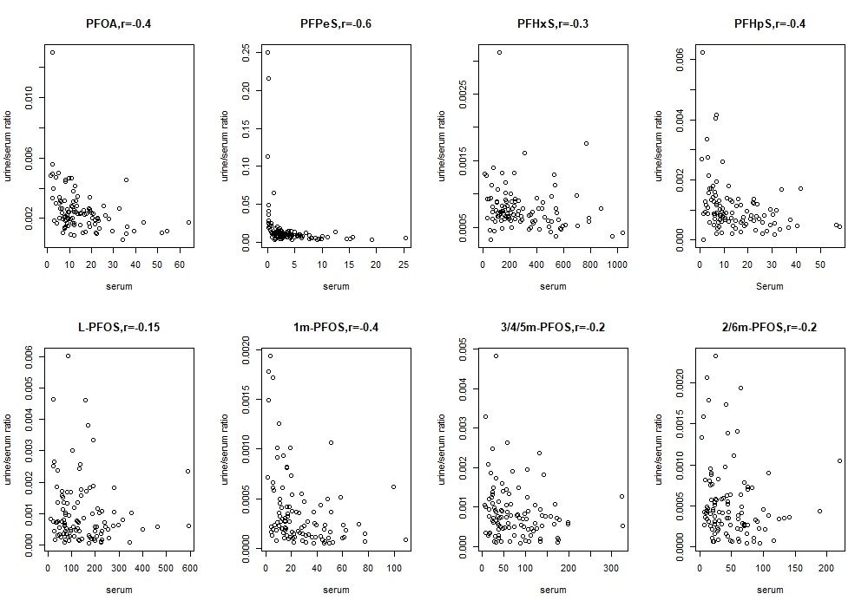
Figure S1. Scatterplot between urine/serum ratio at round 5 sampling and serum PFAS levels
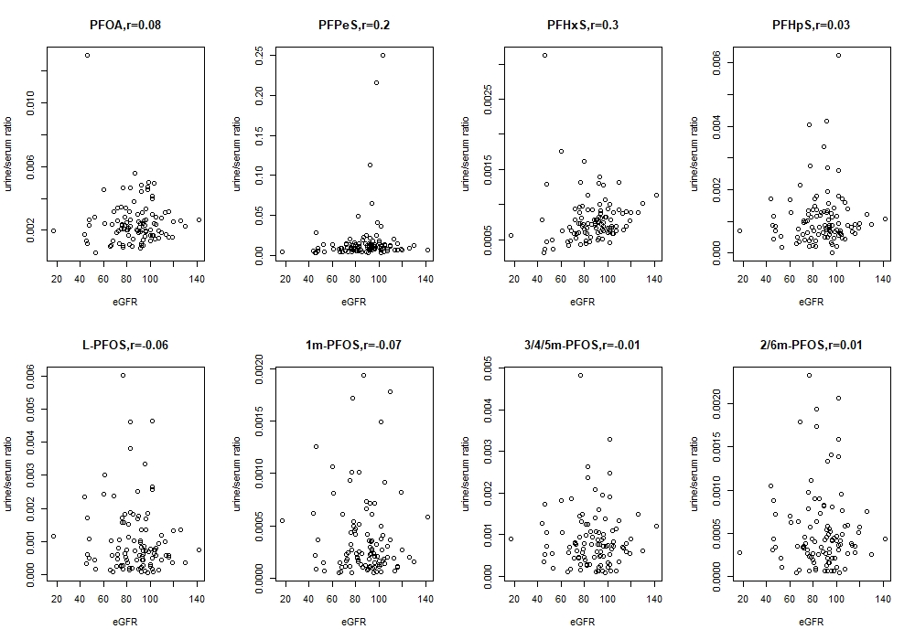
Figure S2. Scatterplot between urine/serum ratio at round 5 sampling and eGFR
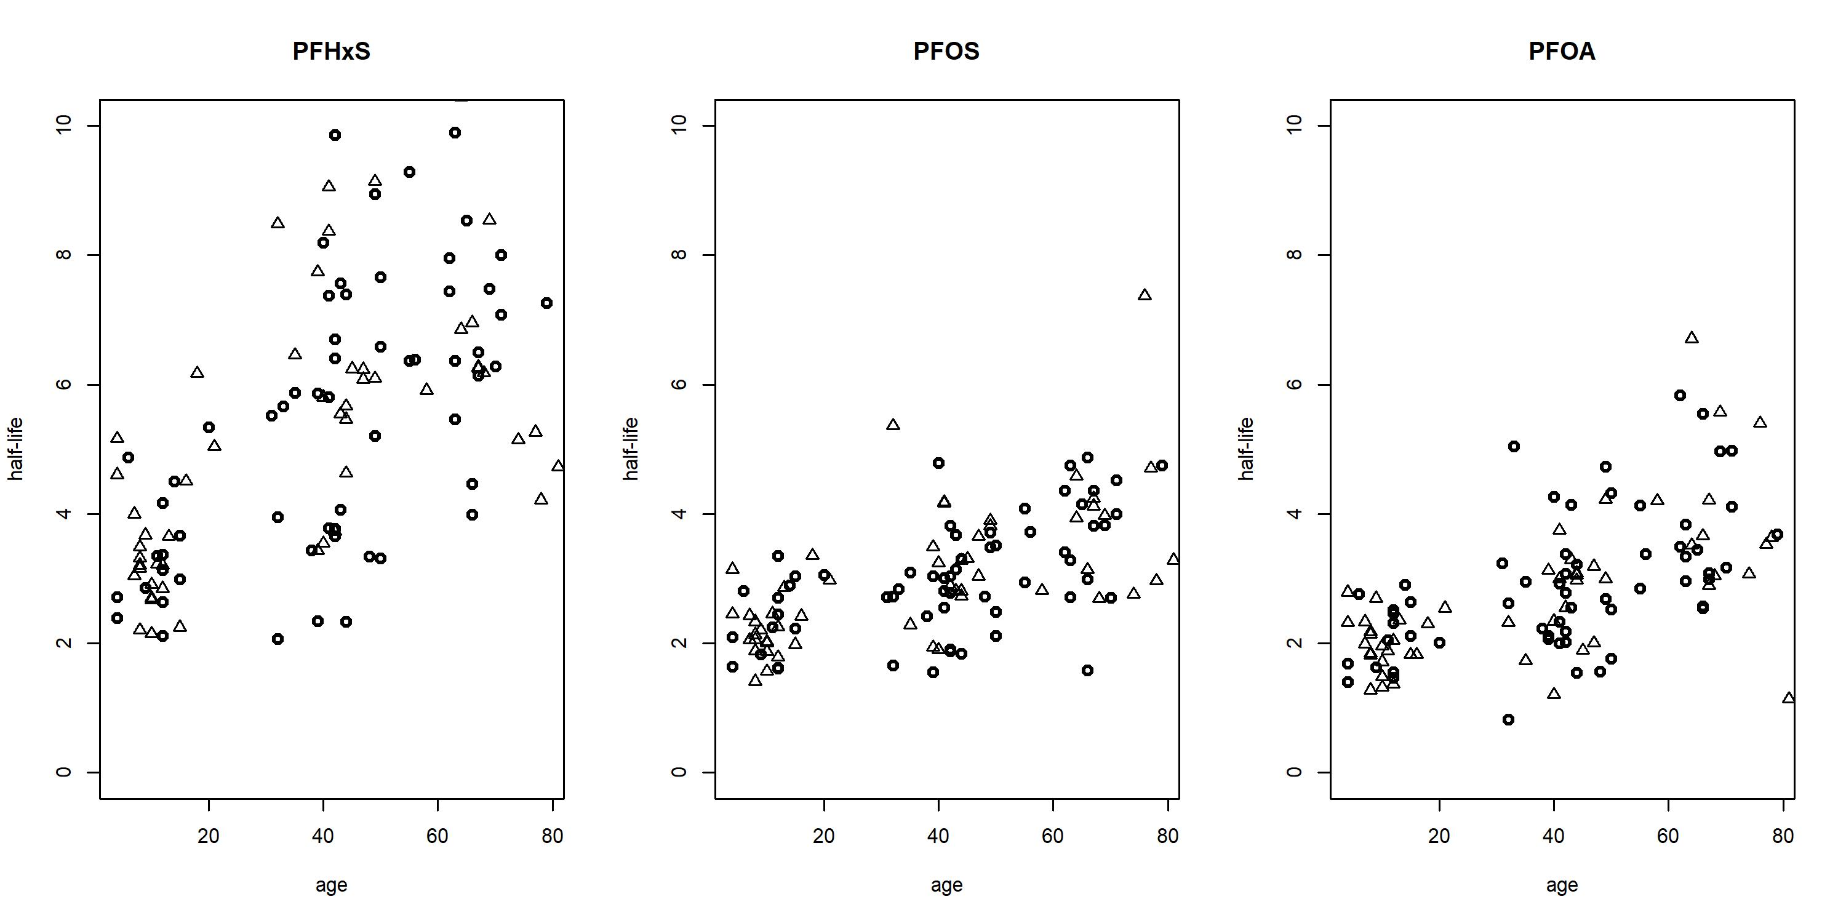
Figure S3. Scatterplot between individual half-life and age with circles represent females and triangles represent males.

